Journal of Animal Ecology
Functional Ecology

Trophic niche partitioning between amphibians and an invasive crayfish promotes their coexistence in pond ecosystems

Coexistence between invasive and native species

Ponds – Aquatic species – Amphibians – Crayfish – Red swamp crayfish

Stable isotopes - Trophic niches – Niche partition – Niche shift – Smaller niches
Nadège Bélouard^{1,2,*}, Eric J. Petit², Julien Cucherousset³, Jean-Marc Paillisson¹
¹ ECOBIO (Ecosystèmes, biodiversité, évolution), Univ Rennes 1, CNRS, 35042 Rennes, France
² ESE (Ecology and Ecosystem Health), Agrocampus Ouest, INRA, 35042 Rennes, France
³ Laboratoire Evolution & Diversité Biologique, Univ Paul Sabatier, CNRS, 31062 Toulouse, France
*Corresponding author: nadege.belouard@gmail.com

Abstract
The species composition of communities is largely shaped by local interactions, notably because in the frame of the coexistence theory, two species with the same ecological niche cannot coexist. The addition of a new species to the community inevitably induce changes in the interactions between species, and the large impacts of invasive species are often linked to their trophic interactions with native species. As a result, the possibilities of coexistence between native and invasive species can be estimated by examining the interactions between them. More, species coexistence can be favoured by a change in the resource use of competing species in order to decrease the overlap of their niches.
The non-native red swamp crayfish, Procambarus clarkii, is considered to dramatically alter aquatic communities, notably because it has a central position in food webs associated to a high trophic flexibility that makes it potentially interacting with several trophic levels in food webs. Its predation on larval amphibians and the modification of resource availability have been shown in experimental conditions, and studying the food webs of natural ecosystems is needed to advance the issue of the coexistence between this crayfish and amphibians in more complex food webs. This work aimed at exploring the trophic interactions between the red swamp crayfish and four species of the amphibian community. We studied the food webs of 20 natural ponds over a gradient of crayfish density by the use of stable isotope analyses and the analyses of niche variation in amphibians and crayfish.
Large variations were recorded in the niche position and size in amphibians, but the niches of crayfish and amphibians never overlapped. Shifts in the niche of two tadpole species were associated to crayfish presence, but also marbled newt densities and pond restoration, while shifts in the niche of two species of adult newts were only associated with pond restoration. These results highlighted that the coexistence between the red swamp crayfish and amphibians may be possible because their direct trophic interactions are restricted. However, crayfish may affect amphibians by indirect relationships such as modifications of resource availability, and further research should be focused on this point. These findings support the view that the niche theory is an adequate way of estimating species coexistence in invaded communities.
The isotopic niche, calculated using stable isotope data, represented the trophic niche.
Keywords: biological invasion, food web, niche partitioning, pond community, stable isotope analysis

Introduction
Invasion theory (Elton, 1958) builds upon classical niche theory (Hutchinson, 1957; Chesson, 2000) in predicting that an invader will lead a native species down to local extinction by competitive exclusion if their niches significantly overlap (Shea and Chesson, 2002; Bøhn et al., 2008; Ricciardi et al., 2013; Tran et al., 2015). A major corollary of classical niche theory is that species coexistence is made possible if at least one species of the pair can adjust its resource use to decrease competitive interactions. Two apparently opposed strategies have been evidenced: the specialization of a species on a few less demanding resources (niche constriction or niche shift, Vander Zanden et al., 1999), as opposed to the increase in the spectrum of resources used to maintain energy requirements (Svanbäck & Bolnick 2007). Both strategies have been identified as ways for native species to cope with invasive competitors in food webs (Olsson et al., 2009; Jackson et al., 2012; Juncos et al., 2015; Tran et al., 2015). Beyond direct competition by niche overlapping, invaders can lead to a more global reorganization of food webs in which they become integrated, with effects propagating throughout trophic levels (David et al., 2017). Omnivorous invasive species are those that have the widest range of effects because they cumulate direct links with multiple levels of the recipient communities, including competition with species of a similar trophic level, and predation with those of upper and lower trophic levels (Snyder and Evans, 2006; Cucherousset and Olden, 2011; Jackson et al., 2017).
Niche theory also predicts that the outcome of trophic relationships varies depending on environmental conditions (Chesson, 2000). While the former has been well integrated (Ricciardi et al., 2013), the latter has often been controlled in studies of trophic consequences of invasions so far, with studies undergone in experimental conditions (see Melbourne et al. 2007), sometimes analyses of natural communities but with limited replication/number of sites (Jackson et al., 2016a; Britton et al., 2018; Jackson et al., 2012; but see Tran et al., 2015). However, not only environmental conditions shape food webs (Post et al., 2000; Doi et al., 2009), but invaders themselves, especially omnivorous ones, can be expected to display variable trophic niches depending on available resources and their depletion, making their impacts much more variable in natural food webs (Evangelista et al., 2014; Jackson et al., 2016b, 2017; Carreira et al., 2017). Studying empirical food webs modified by the insertion of an invasive species is therefore complementary and valuable to determine the outcome of species interactions in the context of biological invasions. Ponds appear as convenient systems to investigate such ecological issues (De Meester et al. 2005), since they combine the advantages of replicability and variability in environmental conditions inherent to natural ecosystems, including that they are frequently invaded by non-native species (REF). Trophic niches can be approached by stable isotope analyses (SIA), a tool based on the predictable relationship between the isotopic signature of a resource and a consumer (Fry, 2006). SIA allow an integrated view of food webs and are particularly appropriate to detect the trophic consequences of invasive species (Cucherousset et al., 2012; Jackson et al., 2012).
Amphibians are a functionally important group in ponds, because of the diversity of life history traits between sympatric species and life stages: tadpoles feed on particles of algae, macrophytes and detritus deposited on the substrate or suspended in the water column (Altig et al., 2007; Whiles and Altig, 2010; Arribas et al., 2015), whereas adult newts mostly feed on macroinvertebrates (Griffiths, 1986; Fasola and Canova, 1992; Denoël and Andreone, 2003; Covaciu-Marcov, 2010). Amphibians also realize crucial transfers of energy between ecosystems with their aquatic larval development and biphasic adult life cycle (REF). This group is declining worldwide (Baillie et al., 2004; Beebee and Griffiths, 2005), and threats notably include invasions of red swamp crayfish Procambarus clarkii. This north-American crayfish has been introduced for commercial purposes in many countries (REF), and has soon been accused of major impacts within receiving communities, notably on amphibians (e.g. Souty-Grosset et al., 2016; Nentwig et al., 2018). With a diet mostly composed of detritus, periphyton and macrophytes, but also of animal preys including macroinvertebrates and amphibians (Correia, 2003; Cruz and Rebelo, 2005; Cruz et al., 2006), it is a benthic omnivorous species, with a high trophic flexibility (Gutiérrez-Yurrita et al., 1998; Correia, 2002; Smart et al., 2002; Alcorlo et al., 2004; Ilhéu et al., 2007). The insertion of crayfish at a central position in food webs is thus expected to considerably modify the trophic structure of pond ecosystems (Sagouis et al. 2015?). Crayfish is thought to impact amphibians notably through trophic relationships, especially predation and competition for food (Cruz and Rebelo, 2005; Cruz et al., 2006). Tadpoles apparently do not recognize crayfish as a predator (Gomez-Mestre and Diaz-Paniagua, 2011) but chemical signals from congeneric tadpoles elicit avoidance behaviors in some species (Pearl et al., 2003; Nunes et al., 2013; Ramamonjisoa et al., 2018) as well as morphological alterations (Nunes et al., 2014; Pease and Wayne, 2014), that could in turn modify their trophic niche. However, the influence of ecological factors on the trophic niche of amphibians was very badly known until recently (Altig et al., 2007; but see Carreira et al., 2016), and SIA have rarely been used to explore this question, because methodological constraints and the requirement of sacrificing animals largely limited explorations until alternative sampling methods were developed for amphibians (Milanovich and Maerz, 2012; Bélouard et al., 2018a). Using SIA, crayfish has been found to alter the isotopic position of tadpoles in mesocosm experiments, as compared to native predators (Caut et al., 2013; Arribas et al., 2015). The effect of crayfish on niche size and the context-dependence of these effects remains unstudied so far.
In the present study, we tested two predictions about the effects of the insertion of the invasive red swamp crayfish in empirical food webs, using stable isotope data as quantitative measures of amphibian trophic niches in 20 ponds. First, crayfish has a documented omnivorous diet, so that the isotopic niches of crayfish and amphibians should overlap as a result of competitive interactions for food resources. Second, amphibians could modify their resource use to cope with the interactions with crayfish, so that we expected smaller or shifted isotopic niches of amphibians in invaded ponds, and this effect should increase with crayfish abundance.

Material and methods

Study area and study species
The study area, situated within the Regional Natural Park of Brière (northwestern France), includes marshes and dense pond networks in a hedgerow landscape. The red swamp crayfish Procambarus clarkii was introduced in one of these marshes in the early 1980s and colonized the ponds closed to it, independently of their other characteristics (Tréguier et al., 2018). Ponds of the study area harbor a total of eight amphibian species (five anurans and three urodeles), four of which are relatively common and sometimes present at high abundances: the agile frog Rana dalmatina, the European tree frog Hyla arborea, the palmate newt Lissotriton helveticus, and the marbled newt Triturus marmoratus. From March until June, larvae of these species develop in ponds; adult newts also stay in the water for the breeding season, while adult agile frogs and tree frogs only spend a few days in ponds to lay eggs and do not properly integrate aquatic food webs (ACEMAV, 2003). The present study thus focused on tadpoles of agile frogs and tree frogs, and adult palmate and marbled newts, but not on larval newts that were too small to be non-lethally sampled for SIA. Food webs were studied in 20 ponds for which we had knowledge on the presence (n = 14) or absence of crayfish (n = 6), in May-June 2016 or 2017 depending on ponds.

Sample collection
In each pond, sampling began in the late breeding season, when tadpoles had developed hind limbs (Gosner stage above 38, Gosner, 1960), to warrant that they attained a stable isotope signature that reflected food resource assimilated in ponds (Trakimas et al., 2011; Caut et al., 2013). The abundance of red swamp crayfish, was estimated using a 12-h trapping session overnight (funnel trap characteristics: length × width × height: 50 × 29 × 21 cm, 5.5-mm mesh size with two side entrances, 4-cm inner opening diameter) set roughly every 5 m along the shoreline in the limits of 4-20 per pond (mean pond perimeter: 66 m, range: 22-172 m). The red swamp crayfish was present at variable abundances in the 14 invaded ponds, with CPUE ranging from 0.11 to 3.55 crayfish/trap/12h. No crayfish was captured in the six other ponds, presumed uninvaded.
The study of pond food webs included resident aquatic consumers (invertebrates, fish, and amphibians). We did not sample all potential food resources because we did not intend to run mixing models. We collected three samples of zooplankton by passing three times 50L of water through a filter of XX µm mesh. Other taxa were caught in traps as described above, using pipe sampling, and by extensive manual research on pond banks: Dytiscidae adults (genus Acilius, Colymbetes, Dytiscus), Dytiscidae larvae, Odonata larvae (genus Aeshnidae and Libellulidae, Zygoptera), Notonecta glauca, larvae of Chironomidae (hereafter Diptera), Gammarus gammarus, Corbiculidae, Physa acuta, fish (black bullhead Ameiurus melas, common roach Rutilus rutilus and mosquitofish Gambusia affinis), adult palmate newts, tadpoles of agile frog, of European tree frog and Corixidae. In each pond, we aimed at sampling 20 individuals of each target species (amphibians and crayfish). Because ontogenetic diet shifts have sometimes been shown in red swamp crayfish (Correia, 2003; Paillisson et al., 2011; Alcorlo and Baltanás, 2013), we considered separately adult and juvenile crayfish. . Each amphibian was sampled using one to two biopsies of the fin of 2.5- or 3-mm diameter (following the recommendations in Bélouard et al., 2018a), and immediately released back to the water. We collected up to three samples of each of the other cited taxa, one sample being composed of up to 15 individuals for macroinvertebrates smaller than Dytiscus spp. (up to 23 for Diptera). All samples were kept on ice during field collection, and then preserved by freezing at -20°C until further processing.

Environmental characteristics
Four habitat characteristics of ponds were considered as proxies of resource availability: (1) canopy cover (% of forested linear of shore), estimated during fieldwork, which is known to influence pond productivity (Skelly et al., 2002; Schiesari, 2006); (2) aquatic vegetation cover (%, visual estimation) that plays a role of resource and refuge; (3) pond area (m²), measured using aerial photointerpretation of a map provided by the General Council of Loire-Atlantique (BD ORTHO 2009) using ArcGIS 10 (Environmental Systems Research Institute, Redlands, California, USA) as it is a proxy of pond hydrological regime, and influence the composition of resident communities (Post et al., 2000); and (4) pond management (canopy opened and pond dredged in the last five years, or not managed). Pond management decreases the availability of detritus material and influences the light regime, and could cause long-term consequences on trophic networks. Additionally, physico-chemical parameters were measured during fieldwork to further characterize pond habitats: dissolved oxygen (mg/L), water temperature (°C) and conductivity (µS/cm) at three locations in ponds (multiparameter probe HI98195, Hanna instruments), and turbidity (NTU) at four locations in ponds (TN-100, Eutech Instruments, Thermo Fisher Scientific).

Stable isotope analyses
In the laboratory, crayfish were measured from the tip of the rostrum to the end of the telson to the nearest millimeter. Length-frequency histograms showed a clear continuous bimodal distribution. A gap was created between the two cohorts by removing few intermediate individuals to better evidence any ontogenetic shift in their isotope signatures. Thus, crayfish were classified as juveniles (< 1 year, mean total length of 42 mm ± 9 SD, range: 25-60 mm) or adults (92 mm ± 10 SD, range: 71-122 mm). Crayfish and fish were dissected to sample abdominal muscle. We used the whole bodies of other macroinvertebrates, mollusks without shells. Zooplankton was sorted from water samples. All samples were rinsed with deionized water, freeze-dried for 48h, and grounded into powder to homogenize tissues except amphibian fins and zooplankton due to the small amount of material available. Each sample was packed in tin capsules: (mean ± SD) 372 ± 63 µg per sample for amphibians, 1 013 ± 63 µg for crayfish, 964 ± 208 µg for other macroinvertebrates, 1 001 ± 53 µg for fish, 1 004 ± 90 for zooplankton, 2 404 ± 929 µg for leaf litter and 2 998 ± 58 µg for macrophytes and algae. We performed SIA for 765 amphibians (271 agile frogs, 179 European tree frogs, 214 palmate newt and 107 marbled newts), 423 crayfish (173 juveniles and 250 adults), 9 fish and 368 macroinvertebrates samples among the 20 ponds (Table 1). The stable isotopes of carbon and nitrogen were measured at the Cornell Isotope Laboratory (Cornell University, Ithaca, NY). Stable isotope ratios were expressed using conventional delta notations δ¹⁵N and δ¹³C relative to international standards, Vienna Pee Dee Belemnite for carbon and atmospheric air for nitrogen, respectively. C:N was calculated as the ratio of elemental composition (%C:%N). In-house standards resulted in a measurement precision of 0.14‰ for carbon and 0.07‰ for nitrogen.

Data analyses
The δ¹³C ratios of animal taxa were lipid-corrected following the equation of Post et al. (2007), and the stable isotope values in amphibian muscle were estimated from the values of the fin samples following the specific equations established in Bélouard et al. (2018a). The isotope ratios of all members of food webs were then standardized to allow comparisons between ponds. Individual trophic positions (TP) were calculated using a baseline composed of primary consumers: the scrappers Physa acuta (n = 0–3 samples), and the filterers Corbiculidae (n = 0–3 samples), for a total of 2 to 6 samples per pond. In the absence of these taxa, we alternatively used zooplankton (n = 3) and Gammarus gammarus (n = 3) in the pond MK, and zooplankton (n = 1) in the pond M949. Special attention was paid to verify that these two ponds were not responsible for any particular tendency in the subsequent statistical analyses. Trophic position was calculated as:
TP = λ + (δ¹⁵N_{c} – δ¹⁵N_{b}) / Δ¹⁵N,
where λ = 2 is the trophic level of primary consumers, δ¹⁵N_{c} is the δ¹⁵N of the individual considered, δ¹⁵N_{b} is the mean δ¹⁵N of the baseline and Δ¹⁵N the trophic discrimination factor (set to 3.4 following Post, 2002; Olsson et al., 2009). Carbon isotopic ratios were adjusted for variations in community width using primary consumers: zooplankton, Corixidae, Physa acuta, Corbiculidae, Gammarus, Diptera and tadpoles. Corrected carbon isotopic ratios were calculated using the following formula:
δ¹³C_{cor} = (δ¹³C_{c} – δ¹³C_{inv}) / (CR_{inv}),
where δ¹³C_{c} is the δ¹³C of the individual considered, δ¹³C_{inv} and CR_{inv} are the mean and range of δ¹³C of the above-cited primary consumers.
For each population of target species, the mean trophic position and the mean δ¹³Ccor were calculated by averaging the isotope values of all individuals. Niche metrics were computed as measures of isotopic niche width (Jackson et al., 2012): total area (TA), carbon range (CR), nitrogen range (NR), centroid distance (CD), mean nearest neighbor distance (MNND), and standard error of the nearest neighbor distance (SDNND), using the R package SIBER (Jackson et al., 2011) and bootstrapped (n = 10.000). Because sample sizes differed and most extreme individuals influence TA, standard ellipse areas corrected for small sample sizes (SEAc) were calculated as a measure of core population isotopic niche (Jackson et al., 2012). The degree of overlap of the isotopic niches between species was calculated on SEAc as %overlap = area of overlap/niche area of the species considered. All these niche metrics were calculated for each population of target species composed of n > 10 individuals (following recommendations in Jackson et al., 2011). In three newt populations, we sampled only 7-9 individuals despite intensive trapping, reflecting their actual abundance in those ponds (Table 1). Because high rates of recaptures attested that the whole population had been sampled, we calculated niche metrics for these populations as well, because we think that they represent a necessary and realistic part of food web variations. We made sure that they were not responsible for particular tendencies in the results. Niche metrics of 44 amphibian populations were calculated in 5, 6, 6 and 6 uninvaded ponds as well as 10, 4, 6 and one invaded ponds, for the agile frog, European tree frog, palmate newt and marbled newt, respectively (Table 1). Niche metrics were also calculated for 13 and 9 populations of adult and juvenile crayfish, respectively.

Statistical analyses
All analyses were conducted in R version 3.5.5 (R Core Team, 2018). Using linear mixed models (R package lme4, Bates et al., 2014), we tested whether the variation in amphibian niche metrics (SEAc, TA, NR, CR, CD, MNND, SDNND) was associated to crayfish abundance, crayfish presence, and the four environmental characteristics (pond area, canopy cover, aquatic vegetation cover and pond management) with amphibian species and pond identity included as random factors. When a random factor was singular, it was removed from the model. All niche metrics were log-transformed to meet assumptions of residuals normality. Aquatic vegetation cover was correlated to area (Pearson correlation coefficients, r = -0.33), canopy cover (r = -0.37) and crayfish abundance (r = -0.45). Canopy cover and crayfish abundance were lower in managed ponds (Mann-Whitney test, p < 0.05), and canopy cover was higher and aquatic vegetation cover was lower in invaded ponds (p < 0.001). Correlations between environmental characteristics are frequent in natural ecosystems, so that we tested each variable alone in models. For each niche metric, models were ranked by the Akaike information criterion corrected for small sample sizes (AICc, Burnham & Anderson, 2003) along with a null model containing only random factors. Models within ΔAICc < 2 were considered equivalent in their probability of best explaining the data (Burnham and Anderson, 2003). Finally, we tested for an ontogenetic shift in the isotopic signature of crayfish with a linear model, using TP or δ¹³C_{cor} as response variable, and crayfish total length, pond, and their interaction as fixed factors.

Results

Species niche metrics and overlap in isotopic space
In most communities, juvenile and adult red swamp crayfish were central (intermediate on both isotopes) while amphibians were situated on the edges of the isotopic space of communities (Figs. 1 to 3). In particular, newts were situated on the right side (high δ¹³Ccor and intermediate to high TP), and Agile frogs on the left side (low δ¹³Ccor and a low to intermediate TP) of communities in most ponds. The position of European tree frogs was less stable on both isotopes. There was a significant positive link between crayfish length and TP in all ponds (range of the estimates per pond: 0.04 +/- 0.001 to 0.01 +/- 0.001, all p < 0.05), except in pond 88 (estimate = -0.002 ± 0.002, p = 0.15).

Table 1. Niche metrics of populations (mean ± SD). N, sample sizes. %trophic network, SEAc_{population}/SEAc_{trophic network}*100
 | N | TA | SEAc | %trophic network | NR | CR | CD | MNND | SDNND
Adult crayfish | 13 | 0.123 ± 0.120 | 0.051 ± 0.035 | 10.7 ± 6.6 | 0.463 ± 0.265 | 0.370 ± 0.172 | 0.159 ± 0.073 | 0.060 ± 0.025 | 0.049 ± 0.022
Juvenile crayfish | 9 | 0.092 ± 0.075 | 0.043 ± 0.030 | 8.4 ± 5.3 | 0.351 ± 0.115 | 0.368 ± 0.185 | 0.145 ± 0.047 | 0.051 ± 0.022 | 0.042 ± 0.016
Agile frog | 15 | 0.127 ± 0.212 | 0.060 ± 0.099 | 7.7 ± 5.6 | 0.291 ± 0.128 | 0.525 ± 0.620 | 0.173 ± 0.160 | 0.053 ± 0.037 | 0.045 ± 0.033
European tree frog | 10 | 0.154 ± 0.106 | 0.073 ± 0.052 | 13.3 ± 11.0 | 0.459 ± 0.207 | 0.563 ± 0.422 | 0.209 ± 0.088 | 0.067 ± 0.025 | 0.058 ± 0.025
Marbled newt | 7 | 0.156 ± 0.134 | 0.079 ± 0.067 | 7.9 ± 3.0 | 0.571 ± 0.092 | 0.373 ± 0.289 | 0.189 ± 0.063 | 0.065 ± 0.035 | 0.054 ± 0.024
Palmate newt | 12 | 0.145 ± 0.146 | 0.069 ± 0.069 | 9.4 ± 4.2 | 0.549 ± 0.206 | 0.353 ± 0.264 | 0.180 ± 0.078 | 0.063 ± 0.034 | 0.053 ± 0.025
Between-pond variance | 20
Between-species variance | 6

In all trophic networks, individuals were rather homogeneously clustered by species, so that (1) the seven niche metrics were positively and significantly correlated to each other (r = 0.45 – 0.99, p < 0.05 after Bonferroni correction), except NR and CR (r = 0.02, p = 0.91), and (2) niches occupied a limited part of the isotopic space of the trophic network (on average 7.7 to 13.3% per species). NR was always < 1 except for adult crayfish in pond K. The variability in population niche metrics was often greater between ponds than between species, except for NR (Table 1).
Standard ellipses of crayfish (adult or juvenile) and amphibians did not overlap in any of the 32 cases of sympatry. Partial overlap sometimes occurred between tadpole ellipses, between newt ellipses, or between the ellipses of the two crayfish stages (e.g. M17, M89, M91).

Link between amphibian niche metrics, and crayfish and environmental characteristics
Niche size (SEAc and TA) and individual variability (CD, MNND, SDNND) were negatively associated to crayfish (presence and abundance), but not niche breadth (CR and NR) nor niche position (mean TP and mean δ¹³Ccor). Indeed, amphibian niche metrics were particularly variable in uninvaded ponds as compared to invaded ponds, so that crayfish presence was actually a predictor of niche metrics as good as crayfish abundance. Crayfish was the only variable retained for CD, but the model selection procedure generally also retained environmental characteristics: niche size (SEAc and TA), CR, MNND and SDNND were positively associated to pond restoration; TA and mean TP were negatively associated to canopy cover; niche size (SEAc and TA) were positively associated to aquatic vegetation cover. Finally, the null model (i.e. the variance linked to pond and species identity) was retained for CR, CD, MNND, SDNND, mean TP and mean δ¹³Ccor, and it was the only model retained for NR and mean δ¹³Ccor.

Table 2. Effect sizes ± SD and explained variance (R²) of variables included in the best model for each niche metrics. Significant variables are in bold.
 | Estimate ± SE |  |  |  |  |  |  |  |  |  | Variance ± SD
Niche metrics | Intercept | Crayfish CPUE | Crayfish presence | Restoration | Aq. veg. cover | Canopy cover | R² | df | AICc | wAICc | (1|Mare) | (1|Species)
SEAc | -3.31 ± 0.12 | -0.3274 ± 0.11 |  |  |  |  | 0.24 | 4 | 98.4 | 0.362 | 0.11 ± 0.32
 | -3.03 ± 0.19 |  | -0.61 ± 0.26 |  |  |  | 0.20 | 4 | 98.8 | 0.3 | 0.13 ± 0.36
 | -3.59 ± 0.16 |  |  | 0.56 ± 0.26 |  |  | 0.19 | 4 | 99.7 | 0.194 | 0.11 ± 0.33
 | -3.33 ± 0.13 |  |  |  | 0.30 ± 0.13 |  | 0.20 | 4 | 100.3 | 0.144 | 0.13 ± 0.36
TA | -2.32 ± 0.19 |  | -0.58 ± 0.26 |  |  |  | 0.1664 | 4 | 103.9 | 0.319 | 0.11 ± 0.33
 | -2.59 ± 0.13 | -0.30 ± 0.12 |  |  |  |  | 0.1811 | 4 | 104.7 | 0.215 | 0.10 ± 0.31
 | -2.84 ± 0.17 |  |  | 0.52 ± 0.26 |  |  | 0.1461 | 4 | 105 | 0.184 | 0.09 ± 0.30
 | -2.64 ± 0.14 |  |  |  |  |  | 0.06722 | 3 | 105.4 | 0.156 | 0.16 ± 0.40
 | -2.61 ± 0.13 |  |  |  |  | -0.28 ± 0.13 | 0.159 | 4 | 105.8 | 0.126 | 0.09 ± 0.30
 | -2.61 ± 0.13 |  |  |  | 0.26 ± 0.13 |  | 0.1456 | 4 | 106.3 | 0.127 | 0.13 ± 0.36
CR | -1.55 ± 0.19 |  |  | 0.53 ± 0.20 |  |  | 0.2851 | 5 | 79.3 | 0.707 | 0.09 ± 0.29 | 0.08 ± 0.28
 | -1.33 ± 0.18 |  |  |  |  |  | 0.1837 | 4 | 81.1 | 0.293 | 0.15 ± 0.39 | 0.08 ± 0.28
NR | -0.88 ± 0.17 |  |  |  |  |  | 0.1716 | 3 | 65.6 | 1 |  | 0.10 ± 0.31
CD | -1.74 ± 0.10 |  | -0.37 ± 0.14 |  |  |  | 0.2536 | 4 | 43.4 | 0.598 | 0.04 ± 0.19
 | -1.91 ± 0.07 | -0.18 ± 0.06 |  |  |  |  | 0.2672 | 4 | 44.2 | 0.402 | 0.03 ± 0.18
 | -1.96 ± 0.08 |  |  |  |  |  | 0.1251 | 3 | 45.4 | 0.351 | 0.06 ± 0.25
MNND | -3.04 ± 0.08 |  |  |  |  |  | 0.05697 | 3 | 52.9 | 0.302 | 0.04 ± 0.21
 | -2.87 ± 0.10 |  | -0.30 ± 0.14 |  |  |  | 0.1508 | 4 | 53 | 0.284 | 0.03 ± 0.17
 | -3.02 ± 0.07 | -0.16 ± 0.06 |  |  |  |  | 0.176 | 4 | 53.3 | 0.244 | 0.03 ± 0.16
 | -3.14 ± 0.09 |  |  | 0.27 ± 0.14 |  |  | 0.1321 | 4 | 54 | 0.17 | 0.02 ± 0.16
SDNND | -3.04 ± 0.10 |  | -0.32 ± 0.13 |  |  |  | 0.1453 | 4 | 54.6 | 0.315 | 0.02 ± 0.15
 | -3.21 ± 0.07 |  |  |  |  |  | 0.03487 | 3 | 55.1 | 0.245 | 0.04 ± 0.19
 | -3.18 ± 0.07 | -0.16 ± 0.06 |  |  |  |  | 0.1626 | 4 | 55.3 | 0.227 | 0.02 ± 0.14
 | -3.32 ± 0.08 |  |  | 0.30 ± 0.13 |  |  | 0.134 | 4 | 55.4 | 0.213 | 0.01 ± 0.11
Mean TP | 2.42 ± 0.10 |  |  |  |  | -0.14 ± 0.05 | 0.1817 | 4 | 50.2 | 0.542 |  | 0.03 ± 0.16
 | 2.42 ± 0.10 |  |  |  |  |  | 0.04241 | 3 | 50.5 | 0.458 |  | 0.03 ± 0.17
Mean δ¹³Ccor | 1.18 ± 0.08 |  |  |  |  |  | 0.4795 | 4 | -46.2 | 1 | 0.002 ± 0.05 | 0.02 ± 0.15

Discussion
The insertion of invasive species in trophic networks … We explored this issue by testing whether the isotopic niche of the invasive red swamp crayfish overlapped with those of four amphibian species in 20 natural ponds, or, alternatively, whether their sympatry was associated to changes in isotopic niche metrics of amphibians. While crayfish and amphibians did not show niche overlap in any case, crayfish was a significantly negative predictor of most niche metrics.

Strong partitioning of the isotopic space between species
The isotopic niche of crayfish did not overlap with that of any amphibian, suggesting that crayfish and amphibians differ in their resource use in ponds. This result was robust to the four amphibian species considered, and to the various environmental conditions and resource availability encountered in the 14 ponds where they coexisted. The absence of niche overlap is surprising because the spatial structure of resources was expected to be low, reducing the possibilities of niche differentiation linked to microhabitats as compared to deeper or larger ecosystems such as lakes for example. More, niche overlap between tadpoles, between newts, or between crayfish stages was also limited. Thus, we evidenced a strong partitioning of the isotopic space that probably reflect a trophic partitioning intended to limit the intensity of competition between ecologically similar species. It can be facilitated by body size in newts, as marbled newts can benefit from largest preys as compared to palmate newts (Covaciu-Marcov, 2010). This result constitutes a major follow-up to standardized experimental designs, … citer biblio.
Also the case in Britton et al. 2018 Funct Ecol: patterns of trophic niche partitioning between the model fishes was evident, with no niche sharing. […] Trophic niche divergence facilitates the integration of introduced species into food webs. […] The initial ecological response to an introduction appears to be a trophic re-organisation of the food web that minimizes the trophic interactions between competing species. […] In entirety, these results suggest that, in freshwater fishes at least, the initial response to an invasion is trophic niche divergence, leading to niche partitioning.
Juncos et al. 2015 Hydrobiologia: “In general, fishes feeding on the same prey were captured in the same depth strata, indicating common use of food and space. Our results provide new evidence on the trophic ecology of a mixed fish community (exotic-native), supporting the idea that native and non-native fishes could be avoiding negative interactions (e.g., competition) through trophic and spatial resource partitioning.”
Competitive exclusion after invasion? Thomas Bøhn Æ Per-Arne Amundsen Biological Invasions 2008
Compare TP tadpoles with Montaña et al. 2018
“we find that syntopic species within habitats occupy distinct isotope niches”
Rodents and marsupials showed clear differences in isotopic niche in all studied sites (Fig 2).
(me) Very rich communities but limited spatial segregation in small and shallow ecosystems: prone to omnivorous diets, and low trophic divergence?
Interestingly, marsupials are also highly concentrated in a small subset of δ13C axis, indicating that theses species rely in similar food sources

The conservative nature of species' isotope niches, i.e. relative stasis across habitats, as revealed in this study allows us to make inferences about the dietary behaviour of each species. For example, both M. namaquensis and R. pumilio generally occurred around the low end of the δ13C and δ15N axes at both habitats in which they were abundant (open grassland and woodland habitats, and open grassland and vlei habitats, respectively).
Specifically, red swamp crayfish were central in pond isotopic space, as expected with their documented omnivorous diet (Correia, 2003; Alcorlo et al., 2004). The low trophic position of tadpoles in most cases was concordant with the expectation that they essentially feed on particles of algae, macrophytes and detritus (Altig et al., 2007; Whiles and Altig, 2010; Arribas et al., 2015). The variable positions that European tree frogs took in some ponds could be due to an opportunistic feeding behavior, like scavenging, a diet which is known in some tadpole species (Altig et al., 2007). The position of newt indicates that they feed on animal resources and this is concordant with the literature (Fasola and Canova, 1992; Covaciu-Marcov, 2010). Newts often had the highest mean δ¹³Ccor within food webs. Opportunistic feeding on terrestrial insects falling into the water is known in newts (Fasola and Canova, 1992; Covaciu-Marcov, 2010) and would typically result in mixed aquatic-terrestrial signatures shifted away from the isotopic ratios of the aquatic community.
A significant ontogenetic change in the diet of crayfish was evidenced in all ponds but one, and confirms to some extent the suggestion made from other studies (Correia, 2002; Alcorlo et al., 2004). The differentiation between juvenile and adult crayfish could lead the two stages to differently affect food webs. Also a form of trophic partitioning between juv and ad. Ontogenetic continuum in resource use
Alcorlo et Baltanas, no ontogenetic change; Trophic continuum rather than trophic levels;

The invasive crayfish associated to smaller, but not shifted amphibian niches
From an isotopic point of view, crayfish presence … We speculate that if these associations reflect a causal mechanism, amphibians decrease their range of resource used (niche breadth) in invaded ponds because of… (hypothesis of niche reduction). This effect would however be linked to …
the results presented here are statistical correlations between observed richness and environmental variables. If it is assumed that these reflect causal relationships, then they provide support for some of the existing management recommendations, but not for others
We initially hypothesized that the effect size of crayfish effects on amphibian niches would be correlated with crayfish abundance more than crayfish presence, especially because crayfish was present at low densities (< 1 ind./trap/24h) in XX/XX invaded ponds (see Bradley et al. 2019 PNAS). However, niche metrics actually better responded to crayfish presence/absence rather than to crayfish abundance. This was due to a higher variance in niche metrics in populations of uninvaded ponds as compared to those of populations of invaded ponds, because of the interaction with pond restoration.
Higher niche sizes or higher interindividual variability in isotopic signatures indicates a species that is more plastic in its resource use. It can be an advantage in very unpredictable ecosystems like ponds (insurance phenomenon).
It is important to note that the inverse correlation between crayfish presence and aquatic vegetation cover or canopy cover was probably not causal, since it does not hold at the scale of the whole study area (see Bélouard et al. 2018b and Tréguier et al. 2018).
Anti-predatory behavior: the predation of crayfish could induce anti-predatory strategies in tadpoles that modify their diet (see the behavioral response of tadpoles to crayfish in Nunes et al., 2013; Polo-Cavia and Gomez‐Mestre, 2014). Second, modification of resource availability: crayfish could strongly modify resource availability through its activity, notably by decreasing macrophyte density and increasing water turbidity (see also Carreira et al., 2014), both being deleterious to tadpoles that feed on suspended particles and macrophytes (Altig et al., 2007; Whiles and Altig, 2010). Here, this habitat modifications could be responsible for the reduction of the range of resources used by tadpoles, and hence, a reduction in niche width. Instead, in mesocosms, this effect rather caused a shift in the resource used (Arribas et al., 2015).
We observed a reduction in crayfish trophic diversity at times of high carp abundance when there was no isotopic niche overlap (measured using SEAc) in the majority of years, suggesting that the two invaders also interacted indirectly, possibly due to behavioural modifications or competition for non-food resources. We infer, therefore, that the variety of available resources declined as a result of carp-induced habitat alteration from 2006 onwards, thus forcing the crayfish to exploit less diverse prey items which resulted in reduced isotopic variability and significantly reduced CDb, SEAc, CRb and SDNNDb values [14]. The alternative scenario, that increased competition for resources would result in a more varied diet to maintain energy requirements, was rejected.
Tran: même pattern entre mesocosms, small ponds, large ponds: This finding supports our hypothesis that where general patterns of trophic niche divergence are detected between the invasive and native species at small spatial scales, these will also be evident at larger spatial scales and in systems of increased species diversity. est ce qu’on trouve pareil que Arribas ? ben non!
2 sides of a coin: displacement = impact, or displacement = adaptative response?

Final note: the challenge of SIA studies in natural ecosystems, & prospects
Studying natural food webs give more realistic insights into the effects of biological invasions and other factors on trophic networks, although it is more difficult to disentangle their relative importance due to the natural occurrence of multicollinearity between habitat parameters. Obtaining sample sizes high enough for statistical analyses can be challenging due to the small size of these ecosystems, especially in species that naturally occur at low numbers like amphibians.
A limitation of this study is that, within any one habitat type, only two to three species were sufficiently represented for detailed investigation of differences in stable isotope niches. Similarly, our sampling protocol does not entail experimental removals, and cannot investigate events in the past. Hence we cannot directly link emerging patterns with competitive effects. [...] However, given our extensive sampling effort (see Methods) it may be that other species simply occur only at very low abundances within our sampling sites.
Prospects: mechanisms. The local coexistence between amphibians and the red swamp crayfish seems possible based on the high differentiation of their niches in these very small ecosystems, and confirms previous results based on their widespread co-occurrence in the study area (Bélouard et al., 2018b). Further research is needed to disentangle their relative effects. Back and forth experimental/natural to explore the mechanisms/test validity in nature. These parameters are better controlled in experimental studies, and indeed, Arribas et al. (2015) found that the niche position (especially the δ¹³C) of tadpoles of several anuran species was strongly linked to the presence of a competitor or a predator, and especially the red swamp crayfish.

Acknowledgements
Red swamp crayfish, amphibians and fish were collected under the permits n°07/2016, 12/2017, 2016/SEE-Biodiversité/070, 2017/SEE-Biodiversité/1145 approved by the Préfecture de Loire-Atlantique, and the biopsies of the fin of amphibians were conducted in accordance with ethics on animal care and permit n°APAFIS#3125-20152071140177v2. This study was funded by the Agence Française pour la Biodiversité (research program supervised by JMP) and the Ministère de l’Education Nationale, de l’Enseignement Supérieur et de la Recherche (PhD Grant to NB). We thank the Parc Natural Régional de Brière, notably J.P. Damien, for supporting our research activities on amphibian ecology, and Adrien Oger and Dominique Huteau for their help in samples processing. The authors declare that they have no conflict of interest.

References
ACEMAV coll. 2003. Les amphibiens de France, Belgique et Luxembourg. Mèze, France.
Alcorlo P, Baltanás A. 2013. The trophic ecology of the red swamp crayﬁsh (Procambarus clarkii) in Mediterranean aquatic ecosystems: a stable isotope study. Limnetica 32: 121–138.
Alcorlo P, Geiger W, Otero M. 2004. Feeding Preferences and Food Selection of the Red Swamp Crayfish, Procambarus clarkii, in Habitats Differing in Food Item Diversity. Crustaceana 77: 435–453.
Altig R, Whiles MR, Taylor CL. 2007. What do tadpoles really eat? Assessing the trophic status of an understudied and imperiled group of consumers in freshwater habitats. Freshwater Biology 52: 386–395.
Arribas R, Díaz-Paniagua C, Caut S, Gomez-Mestre I. 2015. Stable isotopes reveal trophic partitioning and trophic plasticity of a larval amphibian guild (E Gorokhova, Ed). PLOS ONE 10: e0130897.
Baillie J, Hilton-Taylor C, Stuart SN. 2004. 2004 IUCN red list of threatened species: a global species assessment. IUCN--The World Conservation Union: Gland, Switzerland.
Bates D, Mächler M, Bolker B, Walker S. 2014. Fitting Linear Mixed-Effects Models using lme4. arXiv:1406.5823 [stat].
Beebee TJC, Griffiths RA. 2005. The amphibian decline crisis: a watershed for conservation biology? Biological Conservation 125: 271–285.
Bélouard N, Petit EJ, Huteau D, Oger A, Paillisson J-M. 2018a. Fins are relevant non-lethal surrogates for muscle to measure stable isotopes in amphibians. submitted.
Bélouard N, Petit EJ, Paillisson J-M. 2018b. Variable effects of an invasive species on the reproduction and distribution of native species in pond networks. Accepted in Freshwater Biology.
Bøhn T, Amundsen P-A, Sparrow A. 2008. Competitive exclusion after invasion? Biological Invasions 10: 359–368.
Britton JR, Ruiz-Navarro A, Verreycken H, Amat-Trigo F. 2018. Trophic consequences of introduced species: Comparative impacts of increased interspecific versus intraspecific competitive interactions (SC Trullas, Ed). Functional Ecology 32: 486–495.
Burnham KP, Anderson DR. 2003. Model selection and multimodel inference: a practical information-theoretic approach. Springer Science & Business Media.
Carreira BM, Dias MP, Rebelo R. 2014. How consumption and fragmentation of macrophytes by the invasive crayfish Procambarus clarkii shape the macrophyte communities of temporary ponds. Hydrobiologia 721: 89–98.
Carreira BM, Segurado P, Orizaola G, Gonçalves N, Pinto V, Laurila A, Rebelo R. 2016. Warm vegetarians? Heat waves and diet shifts in tadpoles. Ecology 97: 2964–2974.
Carreira BM, Segurado P, Laurila A, Rebelo R. 2017. Can heat waves change the trophic role of the world’s most invasive crayfish? Diet shifts in Procambarus clarkii (HG Dam, Ed). PLOS ONE 12: e0183108.
Caut S, Angulo E, Díaz-Paniagua C, Gomez-Mestre I. 2013. Plastic changes in tadpole trophic ecology revealed by stable isotope analysis. Oecologia 173: 95–105.
Chesson P. 2000. Mechanisms of maintenance of species diversity. Annual review of Ecology and Systematics 31: 343–366.
Correia AM. 2002. Niche breadth and trophic diversity: feeding behaviour of the red swamp crayfish (Procambarus clarkii) towards environmental availability of aquatic macroinvertebrates in a rice field (Portugal). Acta Oecologica 23: 421–429.
Correia AM. 2003. Food choice by the introduced crayﬁsh Procambarus clarkii. Annales Zoologici Fennici 40: 517–528.
Covaciu-Marcov SD. 2010. Feeding of three syntopic newt species (Triturus cristatus, Mesotriton alpestris and Lissotriton vulgaris) from Western Romania. North-Western Journal of Zoology 6: 95–108.
Cruz M, Pascoal S, Tejedo M, Rebelo R. 2006. Predation by an exotic crayfish, Procambarus clarkii, on natterjack toad, Bufo calamita, embryos: its role on the exclusion of this amphibian from its breeding ponds. Copeia 2006: 274–280.
Cruz MJ, Rebelo R. 2005. Vulnerability of Southwest Iberian amphibians to an introduced crayfish, Procambarus clarkii. Amphibia-Reptilia 26: 293–303.
Cucherousset J, Olden JD. 2011. Ecological impacts of nonnative freshwater fishes. Fisheries 36: 215–230.
Cucherousset J, Bouletreau S, Martino A, Roussel J-M, Santoul F. 2012. Using stable isotope analyses to determine the ecological effects of non-native fishes. Fisheries Management and Ecology 19: 111–119.
David E, Thébault E, Anneville O, Duyck PF, Chapuis E, Loeuille N. 2017. Impacts of invasive species on food webs: A review of empirical data. In Network of invasion: A synthesis of concepts, Bohan D, , Dumbrell AJ, , Massol F (eds). Academic Press: Oxford; 1–60.
Denoël M, Andreone F. 2003. Trophic habits and aquatic microhabitat use in gilled immature, paedomorphic and metamorphic Alpine newts (Triturus alpestris apuanus) in a pond in central Italy. Belgian Journal of Zoology 133: 95–102.
Doi H, Chang K-H, Ando T, Ninomiya I, Imai H, Nakano S. 2009. Resource availability and ecosystem size predict food-chain length in pond ecosystems. Oikos 118: 138–144.
Elton CS. 1958. The ecology of invasions by animals and plants. Chicago, IL, USA.
Evangelista C, Boiche A, Lecerf A, Cucherousset J. 2014. Ecological opportunities and intraspecific competition alter trophic niche specialization in an opportunistic stream predator (S Bearhop, Ed). Journal of Animal Ecology 83: 1025–1034.
Fasola M, Canova L. 1992. Feeding habits of Triturus vulgaris, T. cristatus and T. alpestris (Amphibia, Urodela) in the northern apennines (Italy). Bolletino di zoologia 59: 273–280.
Fry B. 2006. Stable isotope ecology. Springer: New York, NY.
Gallardo B, Clavero M, Sánchez MI, Vilà M. 2016. Global ecological impacts of invasive species in aquatic ecosystems. Global Change Biology 22: 151–163.
Gomez-Mestre I, Diaz-Paniagua C. 2011. Invasive predatory crayfish do not trigger inducible defences in tadpoles. Proceedings of the Royal Society B: Biological Sciences 278: 3364–3370.
Gosner KL. 1960. A simplified table for staging anuran embryos and larvae with notes on identification. Herpetologica 16: 183–190.
Griffiths RA. 1986. Feeding niche overlap and food selection in smooth and palmate newts, triturus vulgaris and t. helveticus, at a pond in mid-wales. Journal of Animal Ecology 55: 201–214.
Gutiérrez-Yurrita PJ, Sancho G, Bravo MA, Baltanas A, Montes C. 1998. Diet of the red swamp crayfish Procambarus clarkii in natural ecosystems of the Donana National Park temporary fresh-water marsh (Spain). Journal of Crustacean Biology 18: 120–127.
Hutchinson GE. 1957. The multivariate niche. Cold Spring Harbor symposia on quantitative biology.
Ilhéu M, Bernardo JM, Fernandes S. 2007. Predation of invasive crayfish on aquatic vertebrates: the effect of Procambarus clarkii on fish assemblages in Mediterranean temporary streams. In Biological invaders in inland waters: Profiles, distribution, and threats, Gherardi F (ed). Springer Netherlands: Dordrecht; 543–558.
Jackson AL, Inger R, Parnell AC, Bearhop S. 2011. Comparing isotopic niche widths among and within communities: SIBER – Stable Isotope Bayesian Ellipses in R. Journal of Animal Ecology 80: 595–602.
Jackson MC, Donohue I, Jackson AL, Britton JR, Harper DM, Grey J. 2012. Population-level metrics of trophic structure based on stable isotopes and their application to invasion ecology (S Thrush, Ed). PLoS ONE 7: e31757.
Jackson MC, Britton JR, Cucherousset J, Guo Z, Stakėnas S, Gozlan RE, Godard MG, Roussel J-M, Copp GH. 2016a. Do non-native pumpkinseed Lepomis gibbosus affect the growth, diet and trophic niche breadth of native brown trout Salmo trutta? Hydrobiologia 772: 63–75.
Jackson MC, Grey J, Miller K, Britton JR, Donohue I. 2016b. Dietary niche constriction when invaders meet natives: evidence from freshwater decapods. Journal of Animal Ecology 85: 1098–1107.
Jackson MC, Wasserman RJ, Grey J, Ricciardi A, Dick JTA, Alexander ME. 2017. Novel and disrupted trophic links following invasion in freshwater ecosystems. In Networks of invasion. 2. Band: Empirical evidence and case studies, Bohan DA, , Dumbrell AJ, , Massol F (eds). Elsevier ; Academic Press, an imprint of Elsevier: Oxford London Cambridge San Diego; 55–97.
Juncos R, Milano D, Macchi PJ, Vigliano PH. 2015. Niche segregation facilitates coexistence between native and introduced fishes in a deep Patagonian lake. Hydrobiologia 747: 53–67.
Milanovich J, Maerz JC. 2012. Assessing the use of non-lethal tail clips for measuring stable isotopes of plethodontid salamanders. Herpetological Conservation and Biology 7: 67–74.
Mollot G, Pantel JH, Romanuk TN. 2017. The effects of invasive species on the decline in species richness: a global meta-analysis. In Network of invasion: A synthesis of concepts, Bohan D, , Dumbrell AJ, , Massol F (eds). Academic Press: Oxford; 61–83.
Nentwig W, Bacher S, Kumschick S, Pyšek P, Vilà M. 2018. More than “100 worst” alien species in Europe. Biological Invasions 20: 1611–1621.
Nunes AL, Richter-Boix A, Laurila A, Rebelo R. 2013. Do anuran larvae respond behaviourally to chemical cues from an invasive crayfish predator? A community-wide study. Oecologia 171: 115–127.
Nunes AL, Orizaola G, Laurila A, Rebelo R. 2014. Morphological and life-history responses of anurans to predation by an invasive crayfish: an integrative approach. Ecology and Evolution 4: 1491–1503.
Olsson K, Stenroth P, NyströM P, GranéLi W. 2009. Invasions and niche width: does niche width of an introduced crayfish differ from a native crayfish? Freshwater Biology 54: 1731–1740.
Paillisson J-M, Roussel JM, Tréguier A, Surzur G, Damien JP. 2011. Préservation de la biodiversité face aux invasions de l’écrevisse de Louisiane (Procambarus clarkii), rapport ONEMA/INRA.
Pearl CA, Adams MJ, Schuytema GS, Nebeker AV. 2003. Behavioral Responses of Anuran Larvae to Chemical Cues of Native and Introduced Predators in the Pacific Northwestern United States. Journal of Herpetology 37: 572–576.
Pease KM, Wayne RK. 2014. Divergent responses of exposed and naive Pacific tree frog tadpoles to invasive predatory crayfish. Oecologia 174: 241–252.
Polo-Cavia N, Gomez‐Mestre I. 2014. Learned recognition of introduced predators determines survival of tadpole prey. Functional Ecology 28: 432–439.
Post DM. 2002. Using stable isotopes to estimate trophic position: models, methods, and assumptions. Ecology 83: 703–718.
Post DM, Pace ML, Hairston NG. 2000. Ecosystem size determines food-chain length in lakes. Nature 405: 1047–1049.
Post DM, Layman CA, Arrington DA, Takimoto G, Quattrochi J, Montaña CG. 2007. Getting to the fat of the matter: models, methods and assumptions for dealing with lipids in stable isotope analyses. Oecologia 152: 179–189.
R Core Team. 2018. R: A language and environment for statistical computing. R Foundation for Statistical Computing: Vienna, Austria.
Ramamonjisoa N, Rakotonoely H, Natuhara Y. 2018. Differential vulnerability of two sympatric tadpoles to an invasive crayfish predator. Hydrobiologia 818: 119–127.
Ricciardi A, Hoopes MF, Marchetti MP, Lockwood JL. 2013. Progress toward understanding the ecological impacts of nonnative species. Ecological Monographs 83: 263–282.
Shea K, Chesson P. 2002. Community ecology theory as a framework for biological invasions. Trends in Ecology & Evolution 17: 170–176.
Smart AC, Harper DM, Malaisse F, Schmitz S, Coley S, Beauregard AGD. 2002. Feeding of the exotic Louisiana red swamp crayfish, Procambarus clarkii (Crustacea, Decapoda), in an African tropical lake: Lake Naivasha, Kenya. Hydrobiologia 488: 129–142.
Snyder WE, Evans EW. 2006. Ecological effects of invasive arthropod generalist predators. Annual Review of Ecology, Evolution, and Systematics 37: 95–122.
Souty-Grosset C, Anastácio PM, Aquiloni L, Banha F, Choquer J, Chucholl C, Tricarico E. 2016. The red swamp crayfish Procambarus clarkii in Europe: impacts on aquatic ecosystems and human well-being. Limnologica - Ecology and Management of Inland Waters 58: 78–93.
Trakimas G, Jardine TD, Barisevičiūtė R, Garbaras A, Skipitytė R, Remeikis V. 2011. Ontogenetic dietary shifts in European common frog (Rana temporaria) revealed by stable isotopes. Hydrobiologia 675: 87–95.
Tran TNQ, Jackson MC, Sheath D, Verreycken H, Britton JR. 2015. Patterns of trophic niche divergence between invasive and native fishes in wild communities are predictable from mesocosm studies (F van Veen, Ed). Journal of Animal Ecology 84: 1071–1080.
Tréguier A, Roussel J-M, Bélouard N, Paillisson J-M. 2018. Is it a hindrance for an invasive aquatic species to spread across scattered habitat patches? Aquatic Conservation: Marine and Freshwater Ecosystems 28: 610–618.
Vander Zanden MJ, Casselman JM, Rasmussen JB. 1999. Stable isotope evidence for the food web consequences of species invasions in lake. Nature 401: 464–467.
Vilà M, Espinar JL, Hejda M, Hulme PE, Jarošík V, Maron JL, Pergl J, Schaffner U, Sun Y, Pyšek P. 2011. Ecological impacts of invasive alien plants: a meta-analysis of their effects on species, communities and ecosystems: Ecological impacts of invasive alien plants. Ecology Letters 14: 702–708.
Whiles MR, Altig R. 2010. Dietary assessments of larval amphibians. In Amphibian Ecology and Conservation: A Handbook of Techniques Oxford University Press; 71–86.

Figure captions
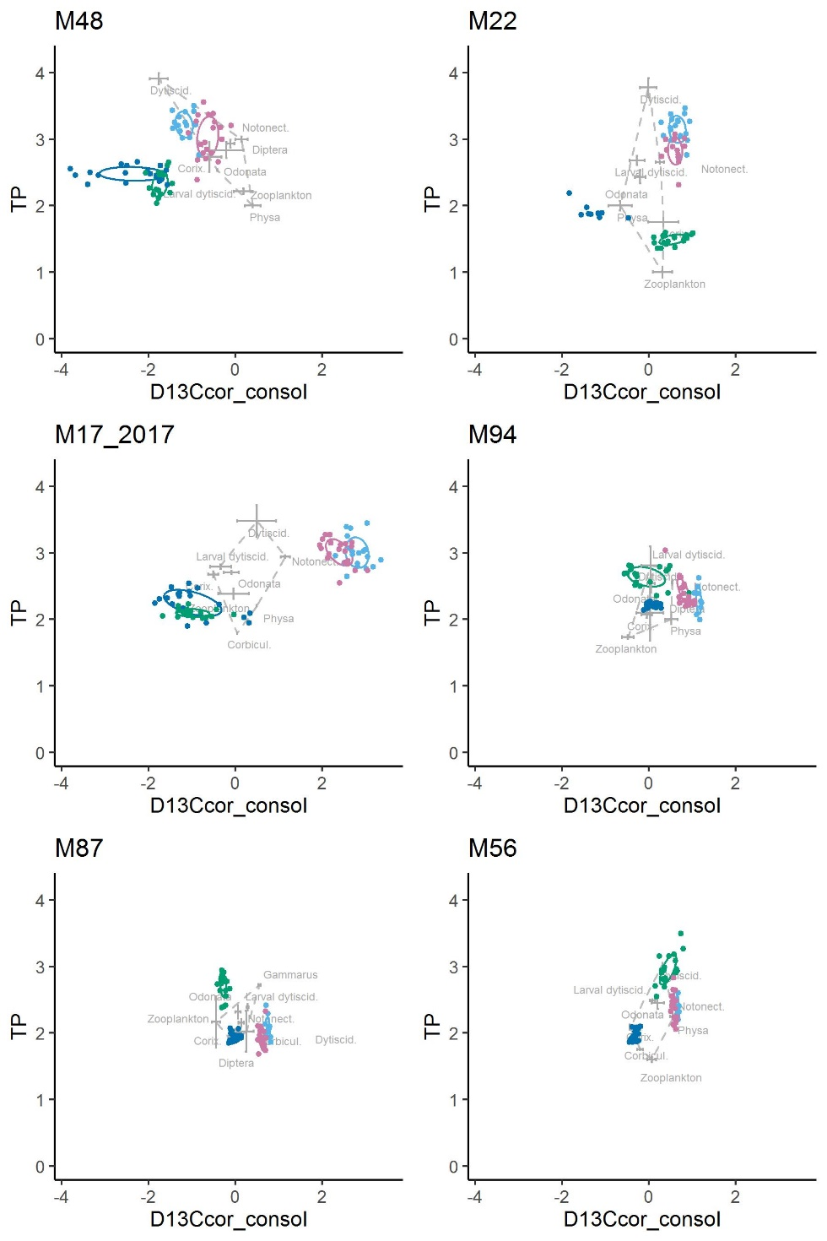

Fig. 1. Plots of the mean ± SE isotope signatures of each uninvaded pond community, and standard ellipses (SEAc) for each target species. Agile frogs, red points, European tree frog, green points, palmate newts, orange points, marbled newts, blue points.

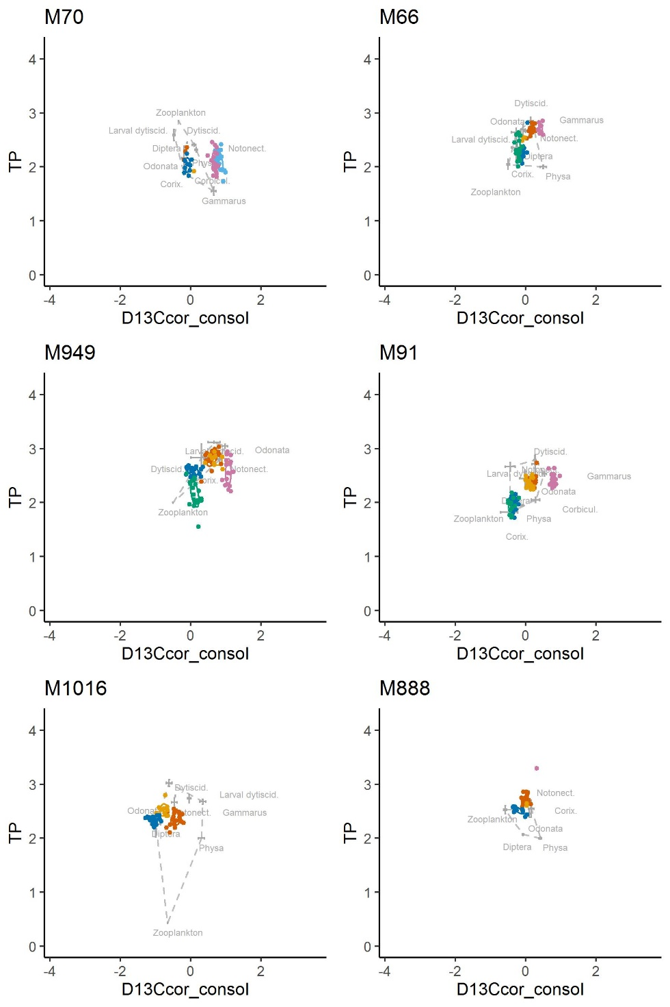

Fig. 2. Plots of the mean ± SE isotope signatures of each pond community with crayfish CPUE < 1, and standard ellipses (SEAc) for each target species. Agile frogs, red points, European tree frog, green points, palmate newts, orange points, marbled newts, blue points.

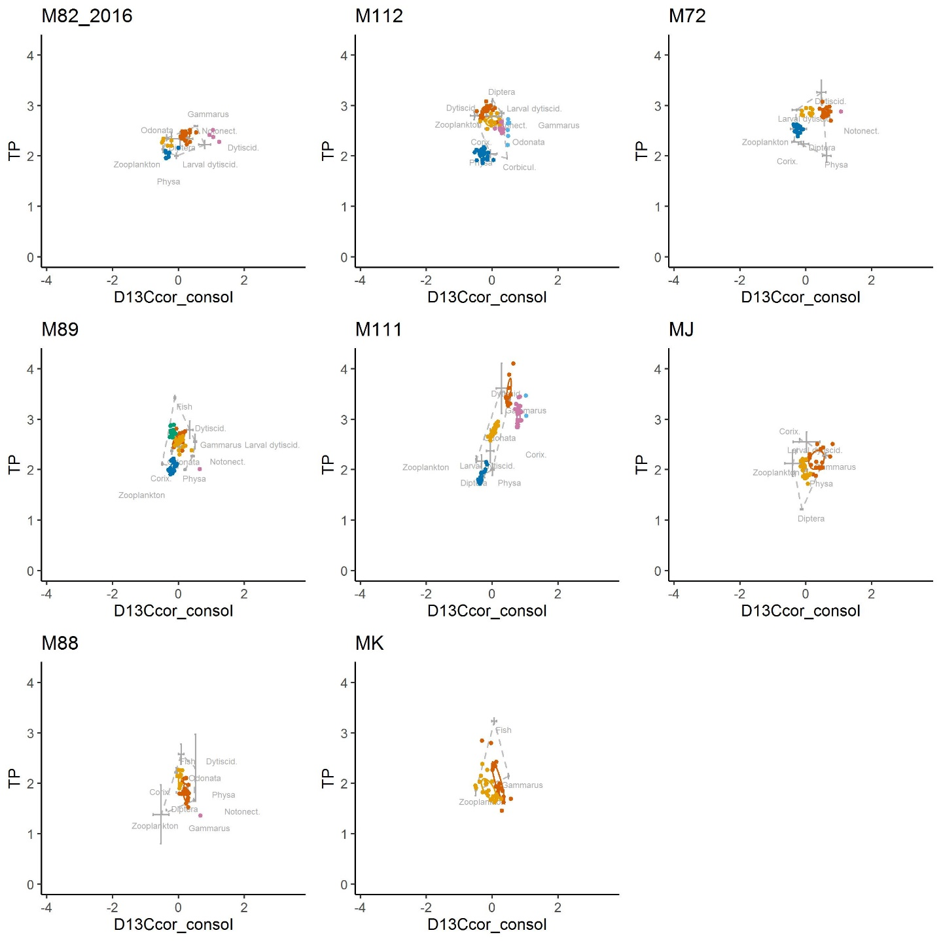

Fig. 3. Plots of the mean ± SE isotope signatures of each pond community with crayfish CPUE > 1, and standard ellipses (SEAc) for each target species. Agile frogs, red points, European tree frog, green points, palmate newts, orange points, marbled newts, blue points.

